**Industrial Project report**

**On**

**“Balaji Wafers Pvt. Ltd.”**

**Submitted to**

**College Code: 385**

**College Name: Government B.B.A. College**

**Under the Guidance of**

**Prof. Jyoti Jain**

**In partial Fulfillment of the Requirement of the award of the degree**

**Of**

**Bachelor of Business Administration (BBA)**

**Offered by**

**Gujarat University**

**Ahmedabad**

**Prepared by:**

**Name:Varja Abhijeet Pareshbhai**

**Second Year**

**Division: A**

**Roll No:4004**

**PREFACE**

**This Project Report has been prepared in partial fulfilment of the requirement for the Subject: Practical Studies of the programmer B.B.A. (Sem. IV) in the academic year 2021-2022.**

**For preparing the Project Report, we have visited the Manufacturing Company, to avail the necessary information. The blend of learning and knowledge acquired during the visit at the company is presented in this Project Report.**

**The rationale behind visiting the manufacturing company and preparing the Project Report is to study the production basics, and its functional areas like marketing department, services, human resource department and financial department.**

**Acknowledgement**

**I wish to express my gratitude to Gujarat University for giving me an opportunity to be a part of such kind of learning experience, which will surely enhance my knowledge and skills.**

**I am grateful Prof. Jyoti Jain for their valuable guidance and cooperation during the course of the project.**

**She provided me with her assistance and support whenever needed that has been instrumental in completion of the project**

**The project has been a great experience, the learning and the exposure, I got through this project was immense and will surely help in my future pursuits.**

**I would like to give my heartful thanks to my parents who always gave me moral support**

**Project Completion Certificate**

**This is to certify that Mr. Varja Abhijeet Pareshbhai , second year student ofGovernment B.B.A. College (Self-financed), Maninagar (Batch: 2020-2023) has carried out the project work as per the syllabus of Gujarat University. He prepared this Annual Project Report entitled ““Balaji Wafers Pvt. Ltd.”**

**Under the guidance and contribution of Prof. Jyoti Jain in making this report during the Academic year 2021-2022 is highly appreciated.**

**To the best of my knowledge the details presented by him are original in nature and have not been copied from any other source.**

**Prof: Jyoti Jain**

**Date 23.02.2022**

**Balaji wafers pvt. Ltd.**

(Section: A)

[(A) COMPANY PROFILE]

**Introduction:**

Balaji wafers limited is india’s leading snack food manufacturers and distributor. Its headquarter is situated in rajkot, Gujarat, india. Bhikhubhai Virani, Chandubhai,and Kanubhai Virani are founders of the Balaji wafer. The company products portfolio includes Flavoured wafers, namkeen, and western snacks.

Chandubhai Virani, the 60-year-old founder and director of Balaji Wafers Private Limited, started making potato wafers in 1982 with a minuscule investment of Rs 10,000 at a shed erected in the compound of his house. He then went on to build a company that has reaped Rs 1,800 crore as turnover in 2017.

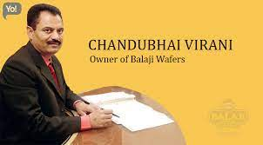

Name : BALAJI WAFERS PVT. LTD.

Address : Vajdi[Vad], Kalawad Road, Rajkot, Tal. Lodhika,Gujarat[India].

Year of establish: 1982

Main products : 1)Wafers (2)Namkeens

Size of unit : Medium Scale Equity

Director :Mr. Bhikhubhai Virani, Mr. Chandubhai Virani, Mr. kanubhai Virani.

Total Area :85,000 Sq.m

Bankers :Corporation and SBI

Phone No :0281-2782755,2783756

Fax :+91 281 2783747

Accounting Year:1st April to 31st March

Email :Contact @balajiwafers.co

Website :Balajiwafers.com

Working hours :8:00 A.M. to 5:00 P.M.

Lunch time :12:00 A.M. to 1:00 P.M.

Weekly off : Sunday

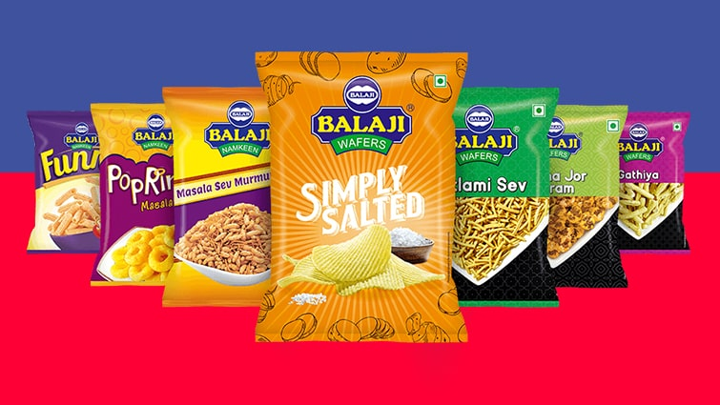

Products:

|  |  |
| --- | --- |
| **Wafers** | **Namkeen** |
| Plain- wafers | Aloo-sev |
| Chat- chaska-wafers | Chana-dal |
| Kela- mari-wafers | Chataka-pataka- masala |
| Masala-wafers | Farali-chevdo |
| Simple-solted- wafers | Gathiya |
| Kela-masala-wafers | Khatta-mitha-mix |
| Tomato-wafers | Ratlamisev |
| Pizzy | Sing- bhujiya |
|  | Chataka-pataka-tomato |
|  | Masala-shing |
|  | vatana |
|  | Sev-mumra |

**Brief History:**

The makers of ‘balaji group’ brand wafers and namkeen food products had deep faith in god & in good taste. Converting dreams into reality it leads then to the biggest potato wafer plant of India. The balaji plant covers over 85000 sq. m area in the outskirts of the Rajkot city. Its big taste revenue i.e. turnover touched to the crore rupees milestone. Balaji group has 90% shares of wafers market and 70% shares of namkeen market in Gujarat.

The journey of balaji group in year 1976 by the members of virani family. For supplying wafer and namkeens of local brands to the patrons of astron cinema, Rajkot. Due to the short supply of that product they decided to make their own product line in year 1982.

By the overwhelming retail success they inspired to set a semi automatic plant. Instead of preparing wafer by the traditional frying method this semi automatic plant boosted the quality, taste and more sales also. The fame of the taste reached to the whole Gujarat hence it was time to takeover the whole Gujarat so the biggest automatic plant of Gujarat came into the picture.

In 1972 Popatbhai sold their agricultural land for $280 ( 20,000 Rupees ) and gave them to enter into business. Virani brothers started a farm equipment business but had the same lack of experience and knowledge regarding marketing. They could not succeed and lost all funds. After these losses Virani brothers haven’t any land for farming, so they went to Rajkot for new opportunities and jobs. In 1994 Virani brothers took the canteen of the Astron cinema. They worked hard and loyally and soon they were asked the owner to run the canteen. In the beginning, they were sold wafers and sandwiches. Virani Brothers noticed wafer packets most sold in the canteen.

**Mission & Vision**

**Mission:**

The company aims to a ‘value for money product’, accessible to consumers all across the country. To accomplish this, the company is seeking to strategically develop a strong and credible distribution network, C&F agents, dealers and retailers.

* Select new products from the existing product line for forward integration.
* Select new processes for the existing products and optimize the process parameters.
* Improve on the processes by adopting new techniques and procedures.
* Work on the efficiency in our services and maintain long standing client relationships.
* To have a sales turnover of 1000 crores by the end of 2019.



**Vision:**

The Company’s Vision, shared by the brothers and the young is to grow into a global giant using modern methods and techniques. The key drivers in this journey of growth will continue to be the age-old traditions of Trust and Quality, without any compromise.

**Location Issue:**

Balaji can’t supply to the new regions from the four plants it has across **Gujrat and Madhya Pradesh**. “A new plant is coming up in uttar pradesh,” he informs. Next would be Delhi-NCR, south and east india. In terms of new products, wafer biscuits would be coming soon, apart from some ethnic snacks.

**Organizational Structure:**

• Organization structure is a basic frame work of company management. It is the pattern in which various parts of the company are interconnected.

• In BALAJI WAFERS PVT LTD. There is a line type of organization in which responsibility flow upward and authorities flow downward and upward.

• The following is the organizational structure of BALAJI WAFERS PVT LTD.

**Awards & Achievements**



**Balaji Wafers awards the media duties to Madison Media**

Madison Media won the media duties worth Rs.20 Crore of the wellknown snacks brand, Balaji Wafers. The company’s media account was put up for a multi-agency pitch for the first time ever. Balaji Snacks and Namkeen will focus essentially on print advertising. Madison Media has been winning the media duties back to back as a few days earlier it had won the media and digital mandate worth Rs 500crore of the health and beauty giant, Marico.MENT

**Achievements**

People’s love is the most memorable achievements. Truly, that helped BALAJI group them to reach its fame across the globe.

Apart from this, economic time recognized balaji group as ‘ SULTAN OF WAFERS’ and international magazine i.e. Asia pacific food online published a special article with ‘ CHIP OFF THE OLD BLOCK’ tag Balaji group is also a member of snacks food association. Balaji group believes in sheer performances which win a accolades of people and media at same time.

**[(B) FINANCE]**

**TURNOVER**

Chandubhai Virani started his business in a shed with mere 10,000 Rs and today his company reaps more than 1,800 crores as turnover. This journey of making Balaji Wafers Private Limited is nothing but an inspiration for one and all.

**2021:**

Balaji is eyeing 22 per cent growth this year to touch ₹3,000 crore by March 2021. “We are growing at a faster pace than the industry average.

Investment in the organization

Firm to invest Rs 25 crore to roll out corn chips.

Balaji Wafers plans capacity expansion of its production unit at Valsad in South Gujarat at the cost of Rs 50 crore. Besides, the company is planning to invest Rs 25 crore for launch of new range of products including corn chips.

“The company has two wafer and snacks manufacturing facilities in Rajkot. Apart from that we have set up a production unit at Valsad with a capacity of 22 tonne wafers an hour. The company is planning to increase the production capacity of wafers and other snack products,” says Chandubhai Virani, Managing Director, Balaji Wafers Pvt. Ltd.

“The Valsad unit that produces potato chips at present would also manufacture snack products with capacity of almost 12 tonnes an hour, which would take the production capacity of the plant to 24 tonnes an hour. The company aims to invest Rs 50 crore for capacity expansion,” added Virani.

The company claims to enjoy a 70 per cent market share in Gujarat while it has 10, 15 and 5 per cent share in Rajsthan, Maharashtra and Madhya Pradesh respectively. To cater the growing demand in Maharashtra, the company has set up a plant in Valsad with an investment of Rs 100 crore.

While commenting on the Valsad plant, Virani added that the production capacity of some of the multinational companies is 18 tonnes an hour, while the Valsad facility produces 22 tonne wafers an hour.

“With an aim to introduce new food products in line with changing lifestyle, the company is going to launch corn chips. We would invest Rs 5 crore to launch the product,” says Virani.

**Capital invested and source of funds**

Snack maker Balaji Wafers is in separate talks with private-equity funds, including Blackstone Group and Actis, to raise between $100 million and $125 million, two sources with direct knowledge of the matter told Reuters.

Snack maker Balaji Wafers is in separate talks with private-equity funds, including Blackstone Group and Actis, to raise between $100 million and $125 million, two sources with direct knowledge of the matter told Reuters.

The company has hired EY to find an investor, said the sources, who declined to be named as they were not authorised to speak to the media.

According to market sources the valuation of the company is around Rs 4,000 crore. Balaji plans to use the funds raised through the stake sale to set up manufacturing facilities in key locations that would facilitate its entry into northern and southern markets.

**[(C) Social Responsibility and future plans of the organization]**

The Company has contributed to the CSR by Supporting Animal Welfare by partnering with various organ…. The Company has contributed to the CSR by Promoting Gender Equality and child protection through Bal…. The Company contributed to the CSR by Promoting Education; an initiative to provide quality education.

Right from its inception, Iscon Balaji Foods is on a path to make a positive impact on the society. With its integrated food production venture, the company intends to make the Indian farmer the real hero and stand distinctly.

We at Iscon Balaji Foods are backed with strong values & ethics of JP Iscon and Balaji Wafers. The agricultural economic state in India is always influenced by the climatic conditions; however, in spite of the various odds put forth by the climate, Iscon Balaji Foods has developed a working model that always proves progressive and beneficial for the farmers. Our company ensures that the farmers not only are able to accumulate knowledge, but are able to get adapted to the latest and innovative techniques in the agricultural domain. This endeavor of our company has led to a better yield for farmers and eventually leading to better finished products for our esteemed consumers.

**(Section:B)**

**[(A) MARKETING]**

**Product portfolio**

Balaji Wafers Limited is India's leading snack food manufacturer and distributor. Its headquarter is situated in Rajkot, Gujrat, India. Bhikhubhai Virani, Chandubhai, and Kanubhai Virani are founders of the Balaji wafer. The company products portfolio includes **flavored wafers, namkeen, and western snacks**.

**Marketing Staff and Structure**

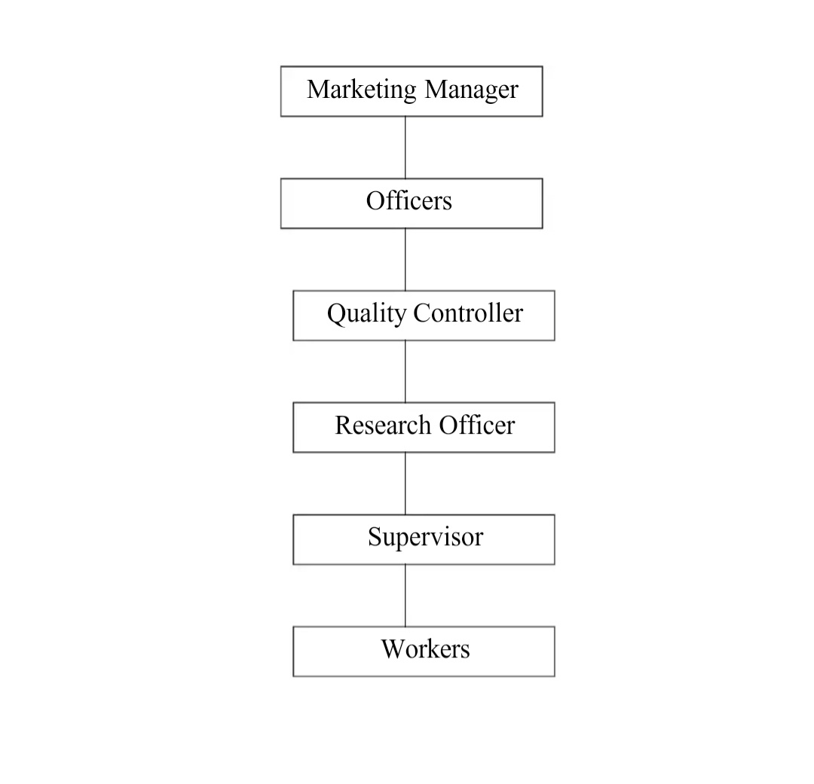

**Marketing Segmentation**

Market segmentation is a subdivision of market as based upon the modern marketing concept , it points out that there is several demand schedules . Each demand schedule represents a separates market consisting of a group of the buyer with similar needs and characteristics of demand. The market segmentation is done on the basis of age, sex,family size, income,education ,occupation , social class, life style etc. the conscious search is made to separate buyer into a number of segments each varying in size, buying behaviour limiting factors for market.

Segmentation are:

1] Rising of cost of project planning and development.

2] Rising unit cost of production.

3] Rising inventory cost for a variety of different lines.

“Marketing srgmentation consists of taking the total heterogeneous market for a product and dividing it into several submarkets , each of which tends to be homogenous in full significant aspects.”

**Philip Kotlar**

In “Balaji wafers pvt ltd”. There is no market segmentation.

Their market is fixed so they think there is no need of market segamentation they produce item according to all classes .and which is also good for the society and firms reputation.

**Stage of PLC**

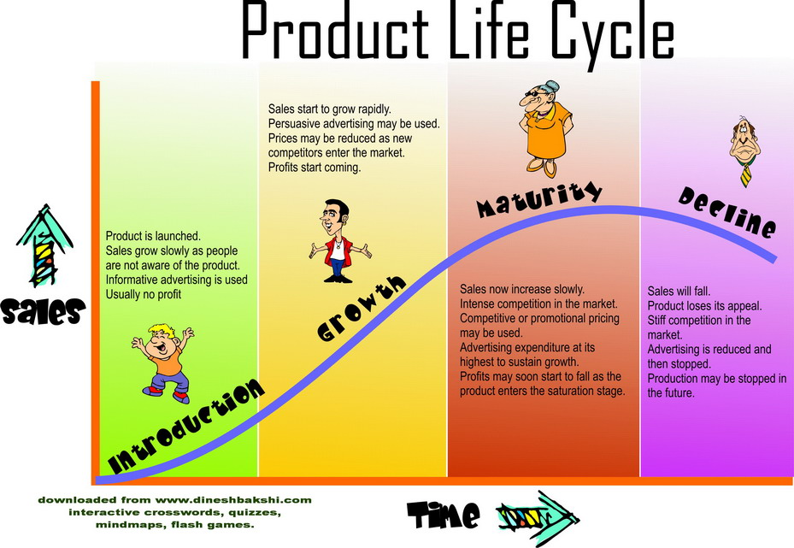

**Product mix**

**Wafers: Namkeen:**

Plain-wafers Aloo-sev

Chat-chaska-wafers chana-dal

Kela-mari-wafers farali-chevdo

Masala-wafers Gathiya

More-wafers Ratlamisev

Simple-solted-wafers mung-dal

Kela-masala-wafers sing-bhujiya

Tomato-wafers masala-shing

Pizzy vatana

Sev-mumra

**Competitor and their strategies**

>Lays from pepsico and parle are the main competitors of balaji (plain salted category)

> Both are targeting Family and children.

>Huge Difference in quantity for lays

> parle has failed to grab the market of salt category for test preferences.

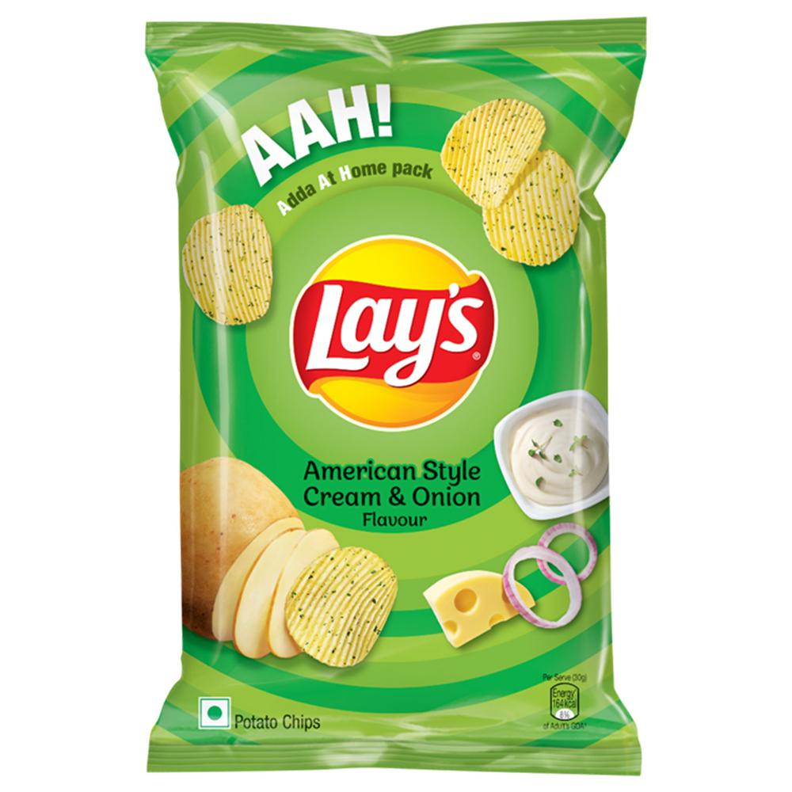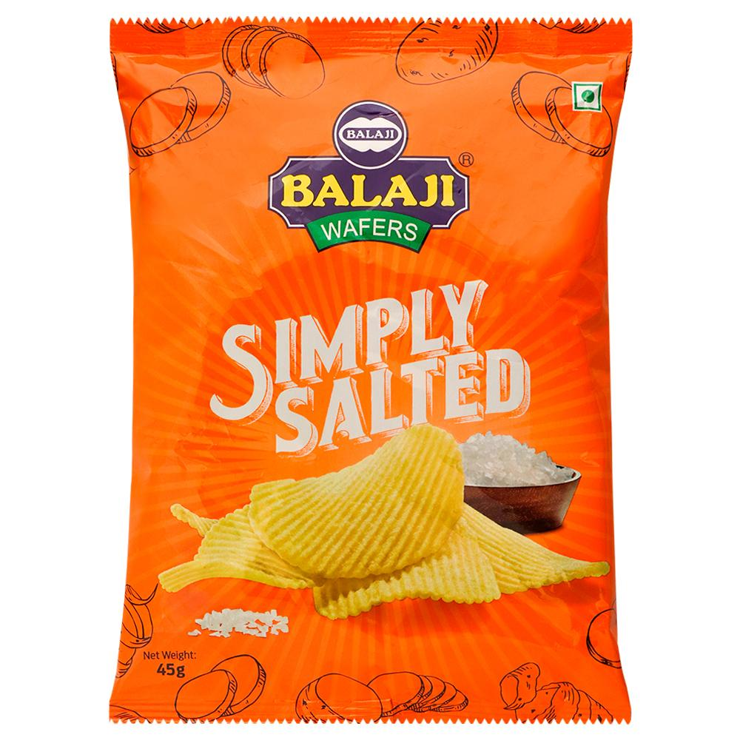

**Marketing Strategies**

* Balaji brand is not an outcome of intensive marketing and advertising campaigns but has been created solely by the importance the company places on delivering quality and affordable products and various CSR initiatives that it has undertaken, making it a classic example of ‘word of mouth’ promotion.
* Balaji do not advertise its products nor run any retail schemes or promotions to sell their products . instead of misspending on superficial aspects like packaging and design which does not really benefit either the company or the consumer, Balaji believes in investing on ensuring that fresh and quality products reach the market.
* Balaji does not use artificial flavours in its snacks and prefers to use local spices which give a made at home taste to its snacks.

**Pricing policies**

“ Decision concerning price to be followed for a period fame may be called as price policies.”

Pricing decision has strategic importance in any enterprise . Good pricing policy is always desired by all organization.

It is also an important element in marketing mix. Mostly we measure the exchange value of any product in terms of money. The price is the components between customers and release about what they are receiving in this money oriented economy price for any product is the value of the item.

“Balaji Wafers Pvt. Ltd.” gives full concentration to the fixation of prices.

**Marketing Channel of Distribution:**

Distribution means the distribution of Goods. The channel of distribution of balaji is no complies. So customer did not wait for the products.

“A channel of distribution for a product is the route take the title of the goods as they move from producer to the ultimate customer of industrial user.”

The Channel of Distribution of Balaji wafers Pvt. Ltd., is as follows:

**BALAJI WAFERS PRIVATE LIMITED**  
**↓**

**Carried & Forwarding**

**↓**

**Super Stockiest**

**↓**

**Dealers**

**↓**

**Retailers**

**↓**

**Consumer**

**PROMOTION MIX**

Promotion is the process of marketing communication to inform, persuade, remind and the influence consumers or users in favour of your product or services.

Promotion is form of communication with a additional element of persuasion to accept ideas, products and service and hence persuasion communication becomes the heart of promotion. In essence promotion is the spark plug of our marketing mix and an important marketing strategy. People must know that right product at the right prices is available at the right time. It is said in a competitive market without promotion nothing can be sold.

In BALAJI WAFERS PVT. LTD, undertakes promotional activities not on very large scale basis. BALAJI WAFERS PVT. LTD also does is promotion through their website, product catalogue, gift, price discount, etc.

**Developing new product**

New product development (NPD) is the process of bringing a new product to the marketplace. Your business may need to engage in this process due to changes in consumer preferences, increasing competition and advances in technology or to capitalise on a new opportunity.

'New products' can be:

* products that your business has never made or sold before but have been taken to market by others
* product innovations created and brought to the market for the first time. They may be completely original products, or existing products that you have modified and improved.

# **New product development strategy**

With a well-considered new product development (NPD) strategy, you can avoid wasting time, money and business resources. An NPD strategy will help you organise your product planning and research, capture your customers' views and expectations, and accurately plan and resource your NPD project. Your strategy will also help you avoid:

* overestimating and misreading your target market
* launching a poorly designed product, or a product that doesn't meet the needs of your target customers
* incorrectly pricing products
* spending resources you don't have on higher-than-anticipated development costs
* exposing your business to risks and threats from unexpected competition.

There are several important steps you will need to plan into your NPD strategy.

**Marketing research activity**

Marketing research is the essential part of any company. In today’s competitive world companies has to do market research to survive in the market. Marketing research may be defined as the scientific and controlled process of gathering of non-routing marketing information helping management to solve marketing problems. Marketing research concentrates on the study of product planning and development pricing policies,effectiveness of personal selling, advertising and sales promotion, distribution structure, marketing strategies, market competition, buyer behaviours and attitudes in the market place.

In “Balaji Wafers Pvt. Ltd.” they also follows the markrting research procedure to find out their consumer demand. In this process first of all requirement of consumers are studied. They try to introduce new facilities every time. Thus, marketing research is an important matter not only for this unit but for also other unit .

**Social responsebility of marketing**

Right from its inception, Balaji Foods is on a path to make a positive impact on the society. With its integrated food production venture, the company intends to make the Indian farmer the real hero and stand distinctly.

We at Balaji Foods are backed with strong values & ethics of Balaji Wafers. The agricultural economic state in India is always influenced by the climatic conditions; however, in spite of the various odds put forth by the climate, Balaji Foods has developed a working model that always proves progressive and beneficial for the farmers. Our company ensures that the farmers not only are able to accumulate knowledge, but are able to get adapted to the latest and innovative techniques in the agricultural domain. This endeavor of our company has led to a better yield for farmers and eventually leading to better finished products for our esteemed consumers.

We aim to offer technical and infrastructural support through latest technology for storing, processing and adding value to farm fresh food items to Indian farmers and enable them to produce better crops and realize the appropriate price for the same.

We pledge to render products that will not only suffice taste buds of consumers retaining nutritional value and hygiene, but will also guarantee that the country as a whole will prosper by strengthening its backbone – Farmers.

**Conclusion**

* Majority of retailers are selling Balaji products.
* Majority of retailers are aware about new product.
* Majority of retailers are satisfied with product delivery of Balaji.
* Majority of retailers want to not launch another product of Balaji instead of that they should be concentrates on existence products and maintain the quality.
* Balaji products are highly selling in the market.

**BIBLIOGRAPHY**

Marketing Management - PHILIP KOTLER.

Marketing Management - S.A.SHARELEKAR.

WEBSITE - www.balajiwafers.com

